# Story 22. Admin can change spots

As an admin  
I want to change which user gets which spot  
so that I can give them spots after the end-date.

## Acceptance criteria:

* The admin can add a user to a spot.
* The admin can remove a user from a spot.

## Wireframes:

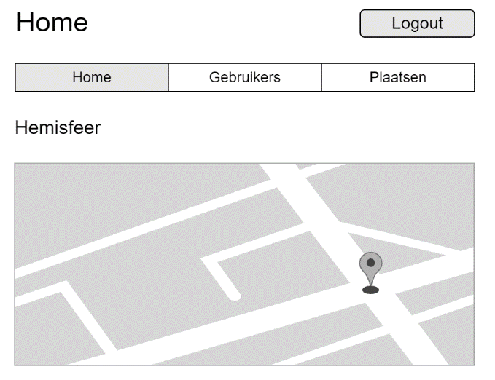

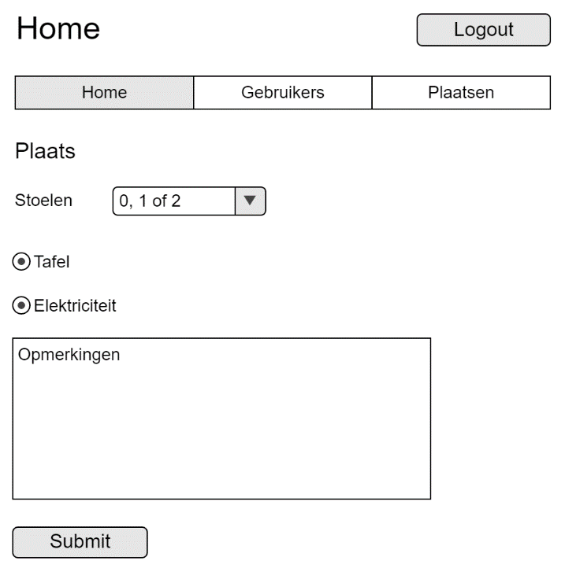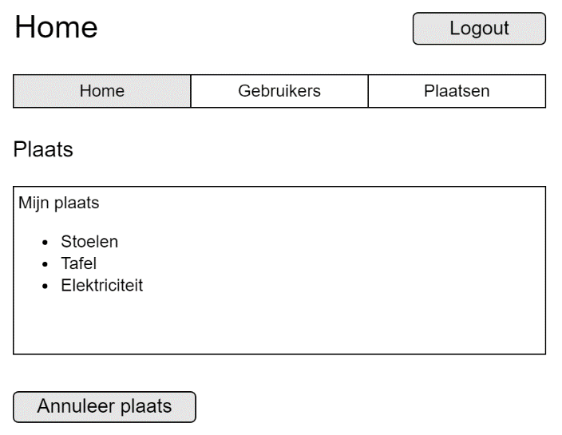

Already reserved

Not reserved